Team Registration Form

Congratulations on being selected to be a team participant of the Basketball Development Academy. Before we begin, please understand this is a serious commitment. We seek athletes who are not only serious about basketball, who want to compete, and have a strong desire to become better basketball players. We also focus on high character athletes who will represent our program well on and off the court. Please fill out the entire form to the best of your ability.
Athlete First & Last Name: _______________________________________________ School: _________________________________________________ Grade: ____________ Athlete Cell Phone: __________________________ Birthdate: _________________
Primary Parent Full Name: _______________________________________________ Parent Cell Phone: ________________________ (NUMBER MUST RECEIVE TEXTS)
Parent E-Mail: _________________________________________________________
Secondary Parent Full Name: ____________________________________________ Cell Phone: __________________ Parent E-Mail: __________________________________________________
Parental Occupation: This section is added for internal networking purposes. As an example, if we have a family looking for assistance with accounting and we have a parent who is an accountant, we try to refer them to people inside our family that we trust. This section is not required to fill in.
Occupation: ____________________________ Job Description: ________________________________ _____________________________________________________________________________________ _____________________________________________________________________________________
Occupation: ____________________________ Job Description: ________________________________ __________________________________________________________________________________________________________________________________________________________________________

Page (1 of7)

“Success is a Habit”
Expectations
Our Goal: Our primary goal for all BDA athletes is to teach maximum effort. This is something each and every athlete has full control over. We are very strict on this subject and will hold each and every athlete accountable for their performance, attitude, and effort levels. Each athlete will get what they put into this season with BDA.
Punctuality: We expect punctuality from all athletes for training sessions, practices and games. Failure to do so may result in loss of playing time, or temporary suspension from game play. We ask that you come to practice 10-15 minutes early and arrive 20-30 prior to our projected game times. We are usually on a tight schedule. Frequent absences and tardiness will not be tolerated.
Communication: A BDA newsletter will be distributed at the end of each month, outlining the upcoming month’s schedule. This newsletter will confirm practice & tournament scheduled for the month, as well as any changes that may occur. You may also retrieve updated information from our BDAHoops.com website. More pressing information and reminders will be sent via group text messages. Please keep our schedule either printed out, on your cell phone or into your personal calendar as a reminder.
Training: We will always have one night of Group Training, and weekly semiprivate/private training sessions in addition to our practices during the week. This program is optional for athletes who are looking to get extra work in during the week to increase their growth. Group Training is an excellent way to rapidly increase an athletes speed, skills, confidence, and overall performance.
Practice: We will typically practice once a week, unless there is a school event in the gym we are using. School events always take priority over rentals. We always do our best to reschedule a secondary practice for the week in the event of a cancelation. Missing practice is unacceptable, ESPECIALLY in the beginning of the season. We learn new things at every practice. We understand that our athletes have busy schedules, but time management and dedication are two very important areas we expect our athletes to possess. Please give us a week’s notice for a missed practice, and 2 weeks’ notice for missed tournaments. Even if athletes are injured, they still need to attend so they can mentally soak in what is being taught at practice and games.
Program Fees
Registration Fees: A one-time registration fee of $275.00 will be due to secure your roster spot. Once that payment is received we will not be able to refund your money as these fees go directly towards team expenses(team & practice uniforms, shooting shirts, team bags, t-shirt) for each player. Athletes keep all gear.

Page (2 of7)
“Success is a Habit”
Team Fees: A monthly team fee of $100.00 is due between the 1-5th of each month. The $275 registration fee includes your first month’s payment of $100 plus $175 fro team gear. Your first payment of $100 will be due the 1st day of the following month after registration. All payments received after midnight on the 5th of each month will automatically be charged a $10.00 late fee. These monthly team fees will cover practice facilities and coaches stipends.
Tournament Fees: We participate in roughly two tournaments a month. Athletes are only charged for the tournaments they participate in. We understand athletes get injured, have family arrangements, etc. The average tournament fee is $20-$30 per tournament. Larger tournaments cost more, no more than $50 at most. Tournament fees are due THE WEEK BEFORE the tournament. Deadlines for tournament fee will be disclosed in monthly newsletters and online. It is very common for parents to add the tournament fees in to their monthly payments. Athletes will not be able to participate without their tournament fees. A $5.00 fee will be assessed for late payments.
BDAHoops Apparel
Please input your players size and circle the desired sizes below:
Top 3 Preferred Jersey Numbers: 1st Choice ________ 2nd Choice ________ 3rd Choice ________ Jersey Top: Y Sm, Y Med, Y Lrg, A Sm, A Med, A Lrg, A XL, A XXL Short Size: Y Sm, Y Med, Y Lrg, A Sm, A Med, A Lrg, A XL, A XXL T-Shirt Size: Y Sm, Y Med, Y Lrg, A Sm, A Med, A Lrg, A XL, A XXL *Y=Youth Size A= Adult Size
(See BDA Apparel on BDA Gear Page)

Player-Parent Agreement
I have read the above information and agree to the terms & conditions of this statement.

Athlete Signature: _____________________________________ Date: ____________

Parent Signature: _____________________________________ Date: ____________

Page (3 of7)
“Success is a Habit”
Concussion Form

A 2009 act requiring the adoption of policies for the management of concussion and head injury in youth sports; amending the Revised Code of 2011 Nev. Stats., Chap. 170 (2011 AB 455)
Requires the Nevada Interscholastic Activities Association and the board of trustees of each school district to adopt policies concerning the prevention and treatment of injuries to the head sustained by students while participating in sports and other athletic activities. This bill also requires school districts and sports organizations that are not governed by the Association to adopt a similar policy. These policies must require the immediate removal of a student from activity or event if the student sustains or is suspected of sustaining a head injury. The student may return to the activity or event after providing a signed medical clearance from a health care provider.
Please read the information below and affix your signature to indicate that you have read this document. This form must be returned to the (Member facility office) and is good only for the current sports season.
A concussion is a brain injury, and all brain injuries are serious. They are caused by a bump, blow, or jolt to the head or by a blow to another part of the body with the force transmitted to the head. They can range from mild to severe and can disrupt the way the brain normally works. Even though most concussions are mild, all concussions are potentially serious and may result in complications including prolonged brain damage and death if not recognized and managed properly. In other words, even a “ding” or a bump on the head can be serious. You can’t see a concussion and most sports concussions occur without loss of consciousness. Signs and symptoms of concussion may show up right after the injury or can take hours or days to fully appear. If your child reports any symptoms of concussion, or if you notice the symptoms or signs of concussion yourself, seek medical attention right away.

Page (4 of7)
“Success is a Habit”
Symptoms may include one or more of the following
Signs observed by teammates, parents/guardians, and coaches include:
• Headaches
• Appears dazed
• “Pressure in head”
• Vacant facial expression
• Nausea or vomiting
• Confused about assignment
• Neck pain
• Forgets plays
• Balance problems or dizziness
• Is unsure of game, score, or opponent
• Blurred, double, or fuzzy vision
• Moves clumsily or displays lack of coordination
• Sensitivity to light or noise
• Answers questions slowly
• Feeling sluggish or slowed down
• Slurred speech
• Feeling foggy or groggy
• Shows behavior or personality changes
• Drowsiness
• Can’t recall events prior to hit
• Change in sleep patterns
• Can’t recall events after hit
• Amnesia • Seizures or convulsions
• “Don’t feel right”
Page (5 of7)
“Success is a Habit”
• Any change in typical behavior or personality
• Fatigue or low energy
• Loses consciousness
• Sadness
• Nervousness or anxiety
• Irritability
• More emotional
• Confusion, repeating same question/comment
• Concentration or memory problems (forgetting game plays)

What can happen if my child keeps on playing with a concussion or returns to soon? Youth athletes with the signs and symptoms of head injuries and/or a concussion should be removed from play immediately. Continuing to play with the signs and symptoms of head injuries and/or a concussion leaves the youth athlete especially vulnerable to greater injury. There is an increased risk of significant damage from a concussion for a period of time after that concussion occurs, particularly if the youth athlete suffers another concussion before completely recovering from the first one. This can lead to prolonged recovery, or even severe brain swelling (second impact syndrome) with devastating and even fatal consequences. It is well known that adolescent or teenage youth athlete will often underreport symptoms of injuries, and concussions are no different. As a result, education of administrators, coaches, parents/guardians, and athletes is the key for youth athlete safety.
If you think your child has suffered a concussion: Any youth athlete even suspected of suffering a concussion should be removed from the game or practice immediately. No youth athlete may return to activity after an apparent head injury or concussion, regardless of how mild it seems or how quickly symptoms clear, without written medical clearance. Close observation of the youth athlete should continue for several hours. The “Zackery Lystedt Law” requires the consistent and uniform implementation of long and well-established return-to-play concussion guidelines that have been recommended for several years: “A youth athlete who is suspected of sustaining a concussion or head injury in a practice or game shall be removed from competition at that time.” “[He or she]...may not return to play until the athlete is evaluated by a licensed health-care provider trained in the evaluation and management of concussion and has received written clearance to return to play from that health care provider.”

Page (6 of7)
“Success is a Habit”
Please inform your child’s coach if you think that your child may have a concussion. It is better to miss one game or even a season rather than having a youth sport participant suffer a catastrophic injury or death. And when in doubt, the athlete sits out. Additional information regarding concussion management is available from the Centers for Disease Control and Prevention (CDC) at: http://www.cdc.gov/ConcussionInYouthSports/. By signing below, I indicate that I have reviewed the information regarding concussions outlined in this document.

_________________________________ ________
Print Athlete Name Age

_______________________________________ Parent/Guardian Signature
_______________________________________________________ Parent/Guardian Name Printed

Date ______________________

Page (7 of7)
“Success is a Habit”
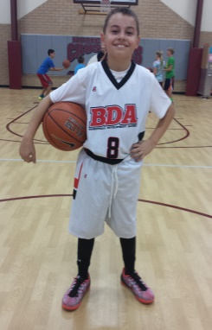

BDA GEAR
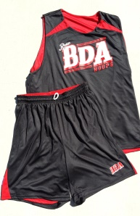
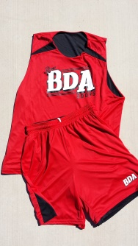
Practice Uniforms

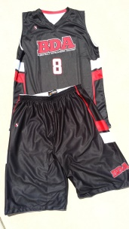
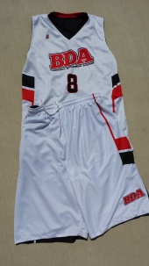
Team uniforms

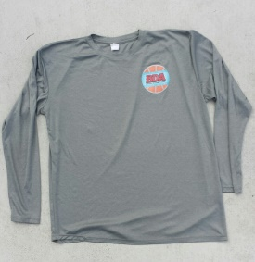
Shooting Shirts

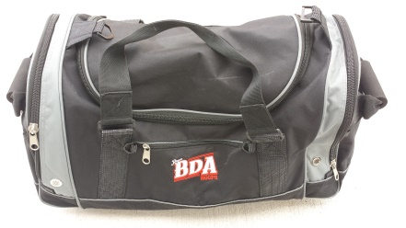
Bags

